

Data Technician

Name: Alaa Mostafa
Course Date: 16/12/24
Table of contents
Day 1: Task 1 2
Day 2: Task 1 2
Day 2: Task 2 3
Day 2: Task 3 4
Day 3: Task 1 4
Day 3: Task 2 5
Dataset: 5
Step 1: Create a Pivot Table 5
Step 2: Use the SWITCH Function 5
Submission: 6
Day 3: Task 3 6
Day 4: Task 1 7
Course Notes 9
Additional Information 10

Day 1: Task 1

Please complete the below boxes on commons laws and regulations that must be followed when working with customers data, use the below bulleted list to support your answers.

- What is it
- Why is it important
- Provide a real-world example of how you can follow it
- How does it impact working with data
- What could happen if you breached it

Data Protection Act | UK Law, What is it: UK law protecting personal data, Why is it important: Upholds privacy, builds trust, avoids UK fines. Real-world example: Securely storing UK customer addresses for deliveries. How it impacts data work: Follow data principles, respect UK data rights. Breach consequences: UK fines, bad reputation.
GDPR | EU Law. What is it: EU law protecting personal data in the EU. Why is it important: Standard for EU privacy, avoids EU fines for EU customers. Real-world example: Getting EU user consent for website cookies. How it impacts data work: Follow EU data rules for EU individuals. Breach consequences: Big EU fines, EU legal trouble.
Freedom of Information Act | What is it: Public right to ask UK public bodies for info. Why is it important: Makes public organizations open and accountable. Real-world example: Providing council meeting notes when asked. How it impacts data work: Public data access, know what can be shared. Breach consequences: Bad reputation, ICO trouble, loss of trust.
Computer Misuse Act | What is it: Law against unauthorized computer access (like hacking). Why is it important: Protects systems and data, prevents cybercrime. Real-world example: Only looking at customer data you're allowed to. How it impacts data work: Need permission to access data, don't harm systems. Breach consequences: Fines, jail, losing your job.

Day 2: Task 1

Please research and complete the following tasks within the retail-sales_dataset.xlsx document, paste a print screen into the provided boxes below:

- In the sheet ‘retail_sales_dataset’ add all available data between columns A –J into a ‘table’
- Using the ‘sort’ function, sort ‘Age’ to ‘largest to smallest’
- Using the ‘SUM’ function, show me the commission total in cell ‘L10’
- Using the ‘AVERAGE’ function, show me the average commission in cell ‘L11’

Print screen 1 | 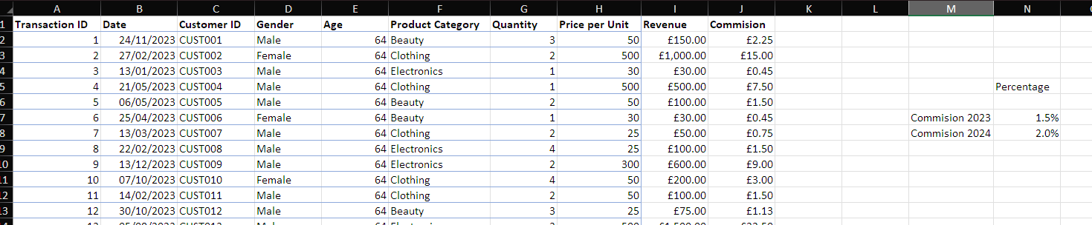
Print screen 2 | 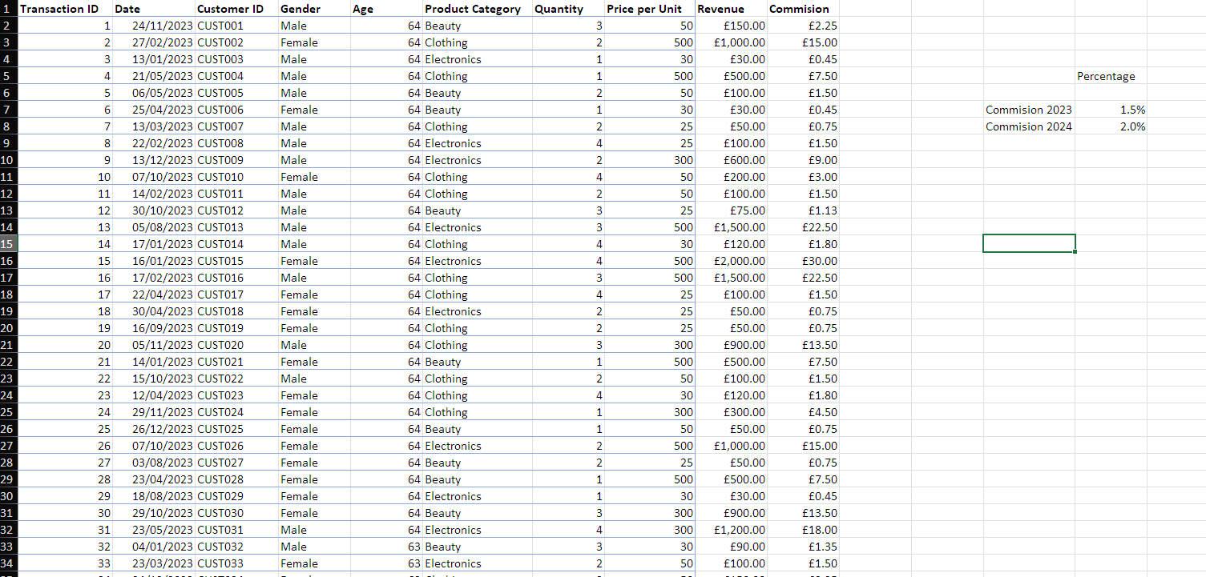
Print screen 3 | 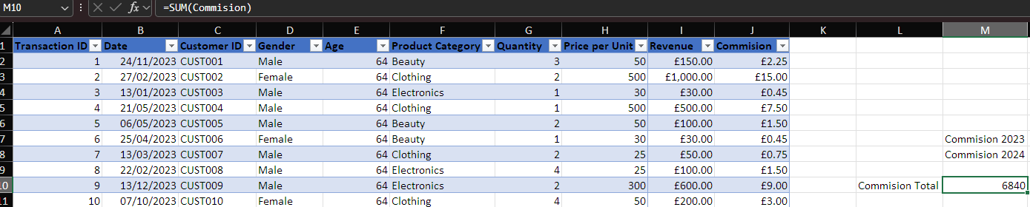
Print screen 4 | 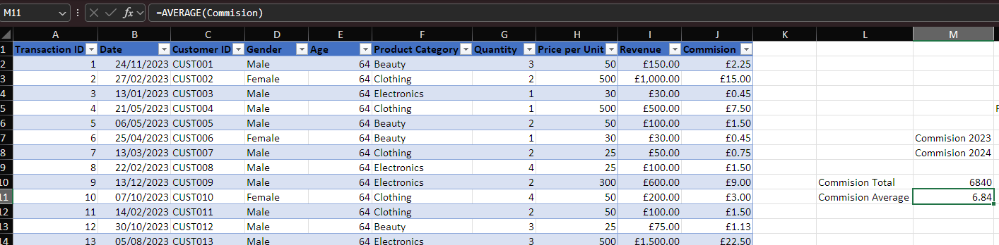

Day 2: Task 2

Please research and complete the following tasks within the retail-sales_dataset.xlsx document, paste print screens into the provided box below:

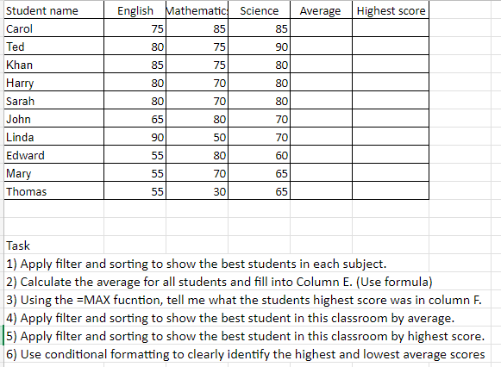

Print screen 1 | 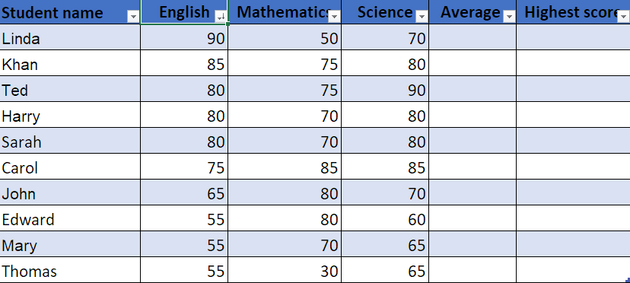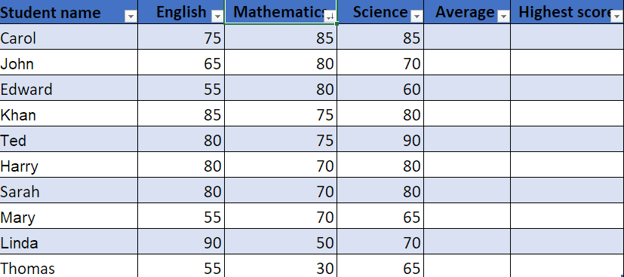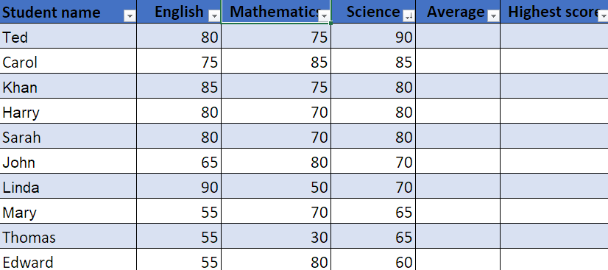
 | 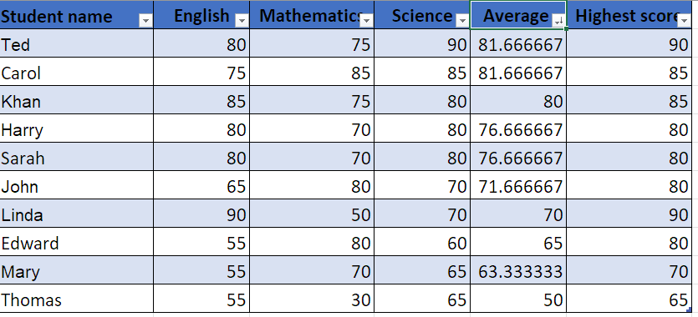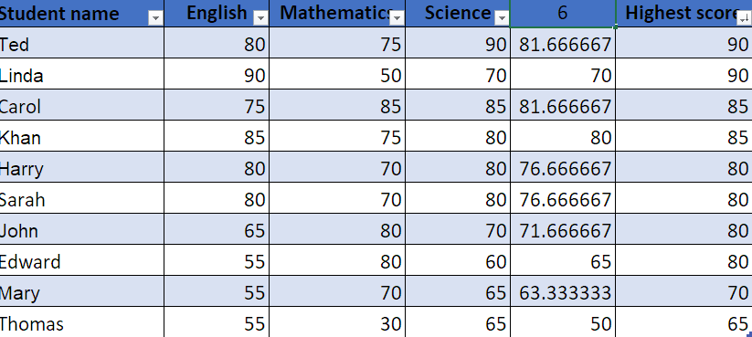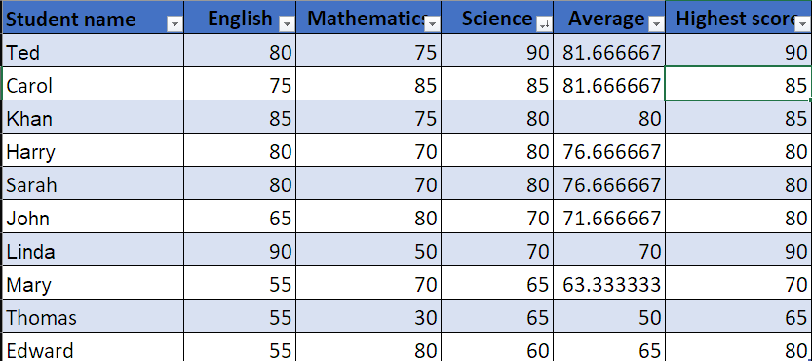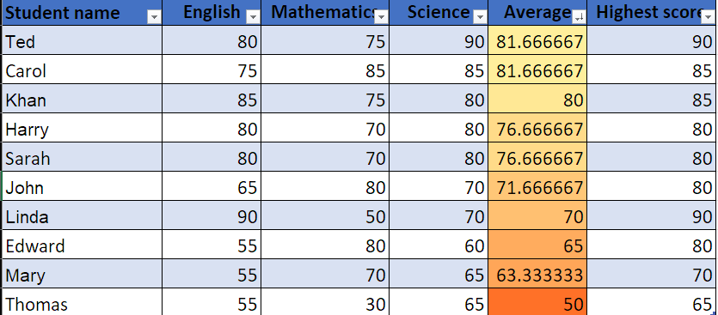

Day 2: Task 3

Using the skills developed today, have some fun with the data set you have imported. Paste your work below and enjoy!

Print screen 1

Day 3: Task 1

Please download the dataset ‘Day_3_Task_1_Bike_Sales_Pivot_Lab.xlsx’ from here.

The lab instructions can be found here. Do not worry if you do not complete the lab, just working with data and playing with the pivot table will be good experience.

Please paste your final pivot table below and complete the reflection questions:

Print screen 1 | 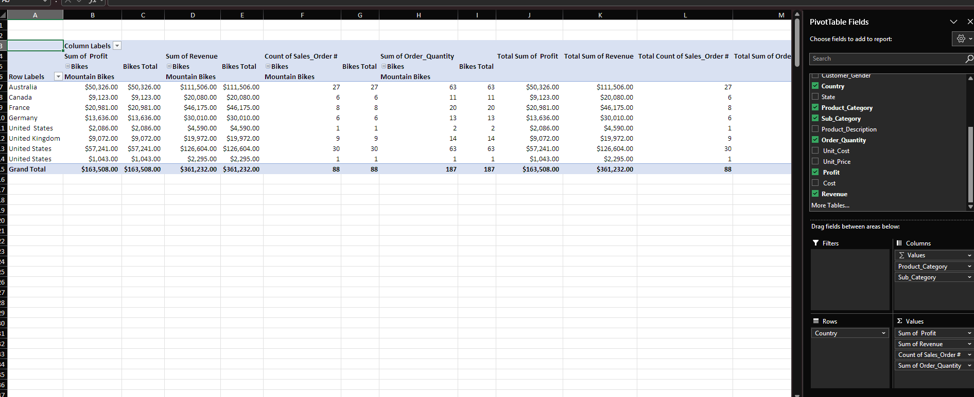
In which markets does Germany have customers? | 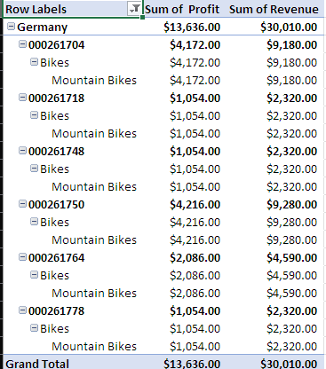
What country has sales in all markets? | 
What are the most profitable markets by country, age group, and gender? | 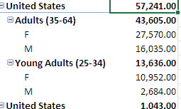
Any other findings? | Couldn’t sort it largest to smallest with a drop down for some reason.

Day 3: Task 2

The dataset below tracks the sales performance of different products in various counties in England. Please paste the dataset into a blank Excel workbook. Your task is to:
- Create a Pivot Table to summarise the data by county and product.
- Use the SWITCH function to categorise products based on their sales volume.

Dataset:
County | Product | Sales Volume
Yorkshire | Laptops | 500
Yorkshire | Smartphones | 200
Cornwall | Laptops | 700
Cornwall | Printers | 400
Lancashire | Smartphones | 150
Lancashire | Laptops | 600
Essex | Printers | 800
Essex | Smartphones | 300
Durham | Laptops | 250
Durham | Printers | 300
Greater Manchester | Smartphones | 600
Greater Manchester | Laptops | 400

Step 1: Create a Pivot Table
- Select the dataset (columns A to C).
- Insert a Pivot Table to summarise the data by County in the rows and Products in the columns. Use Sales Volume as the value to be summarised.

Step 2: Use the SWITCH Function
In a new column next to your data, use the SWITCH function to categorise products based on Sales Volume as follows:
  - For sales greater than 600: "High"
  - For sales between 300 and 600: "Medium"
  - For sales less than 300: "Low"
SWITCH Function Example:
=SWITCH(TRUE, C2 > 600, "High", C2 >= 300, "Medium", "Low")
- Apply this formula to each row, and check if the products are categorised correctly.

Submission:
- A completed Pivot Table summarising sales by county and product.
- A new column in the dataset categorising products by sales volume using the SWITCH function.
  - Please paste your completed work below

Print screen 1 | 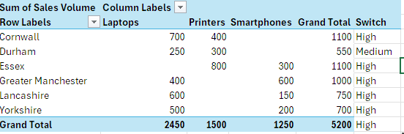

Day 3: Task 3

Please download the dataset ‘Day_3_Task_3_Bike_Sales_Visualisations_Lab.xlsx’ from here.

The lab instructions can be found here. Do not worry if you do not complete the lab, just working with data and playing with the charts will be good experience.

Please paste your results below:

Print screen 1 | 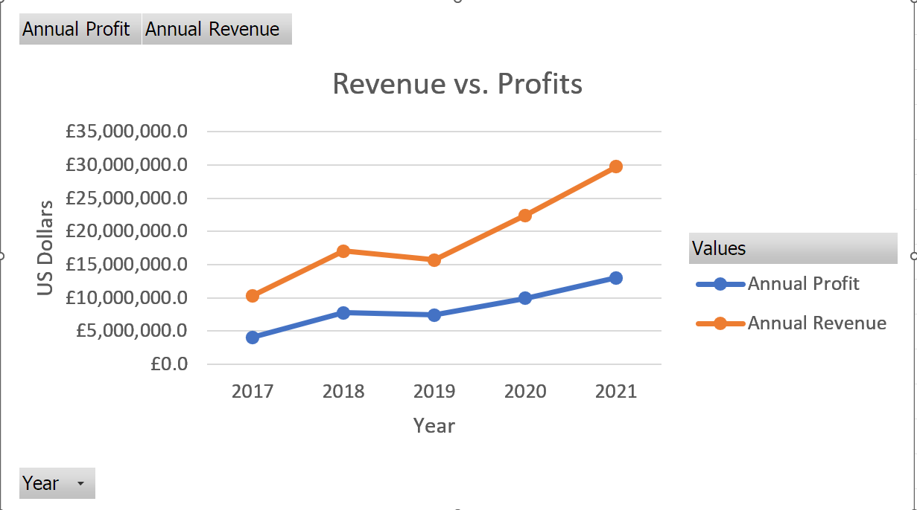  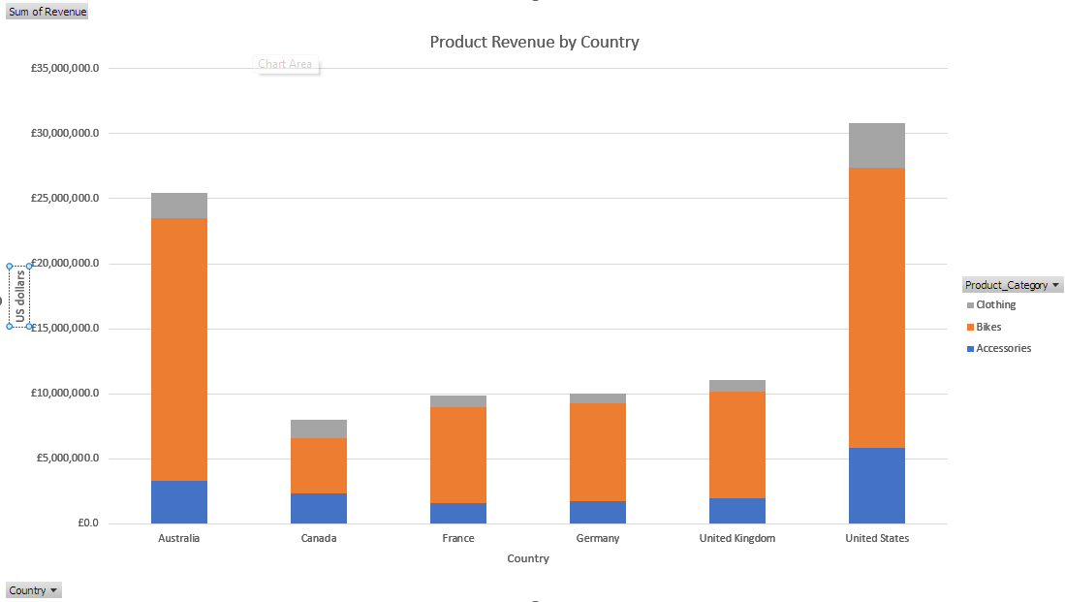  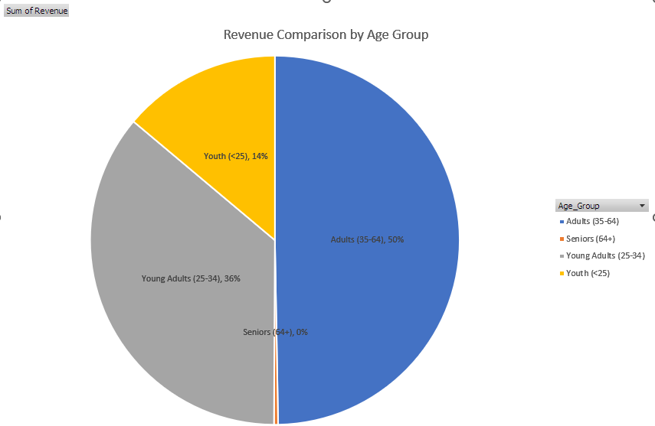

Day 4: Task 1

You have been asked to deliver your analysis findings to the board of directors, with your analysis you have identified that customers are leaving your company at the 12-month point, this is typically when they receive their renewal price.

Conduct research and complete the below questions:

How would you prepare for the delivery? | To prepare for the delivery, I’d start by really knowing my analysis inside and out. I’d make sure I can clearly explain what the data shows and what it means for the business — especially the key takeaway about customers leaving at the 12-month mark.  Next, I’d keep the presentation focused and visual — using charts, a few key stats, and short bullet points. The goal is to make it easy for the board to follow, even if they’re not deep in the data every day.  I'd also prepare a short story around the problem: what's happening, why it's important, and what we can do about it. And of course, I'd be ready for questions — especially around how we can improve retention or make the renewal process more appealing.
What tools would you use for the delivery? | For the delivery, I’d use a combination of tools that help me present the analysis clearly and professionally:  - PowerPoint or Google Slides – To create a clean, visual presentation that highlights the main findings and recommendations.  - Excel – To show the pivot tables, charts, and breakdowns behind the analysis if anyone wants to dive deeper into the numbers.
What is prospecting and why would you complete this before your delivery? | Prospecting is all about understanding who your audience is before you deliver your presentation. It’s about asking: Who’s going to be in the room? What do they care about? What kind of questions might they ask?  By doing this early, I can shape my message to actually connect with them. For example, if I know the board is mostly focused on customer retention and revenue, I’ll highlight those points more in the analysis, instead of getting lost in the technical details.  It also helps me prepare answers for possible concerns, and make sure I’m speaking their language — not just presenting data, but telling a story that makes sense to them and helps them make decisions."
Tell me best practices for public speaking and providing updates to senior leaders | When you're speaking to senior leaders, it's important to keep things clear and straight to the point. Start with the key takeaway — what they really need to know right away — and avoid going into too much background unless they ask for it. Keep your language simple and avoid too much jargon. Make sure you understand what matters most to them, like revenue, performance, or customer impact, and focus your message around that. Use data, but tell a story with it — explain what the numbers mean and why they matter. Stay calm and confident when speaking, and if you don’t know the answer to a question, it’s okay to say you’ll follow up. If you're using slides, keep them clean and easy to read — don’t overload them with text. And finally, always end with a clear recommendation or next step so they know what you're asking or suggesting. The goal is to be clear, focused, and helpful.
What will you show the board in your delivery? | In my delivery to the board, I will walk them through the key insights we’ve gathered, keeping the tone clear and straightforward. I’ll start by highlighting that we’ve identified a pattern where many customers are leaving the company around the 12-month mark, which typically lines up with their renewal period. This suggests that our current approach to renewals—possibly pricing or communication—might be causing customers to walk away. I’ll then show a breakdown of our most profitable markets by country, age group, and gender, helping the board understand where we’re performing strongly and where we might have untapped potential. I’ll include a simple categorisation of product performance based on sales volume, using labels like High, Medium, and Low, so they can quickly see what’s working and what’s not. I’ll also touch on the potential revenue loss caused by this 12-month churn and explain why it’s important we act before it grows. Finally, I’ll share a few clear and practical recommendations—such as reviewing our renewal pricing strategy, improving how we communicate with customers before renewals, and possibly offering incentives to stay. The whole presentation will be kept simple, visual, and focused, using easy-to-read graphs and charts, so the board can quickly understand the issue and see the value in taking action.
How will you articulate the changes that are needed? | I’ll explain the changes in a clear, calm, and confident way, focusing on what the problem is, what it’s costing us, and what we can do about it. I’ll start by briefly restating the issue—customers are leaving us at the 12-month mark, right when they get their renewal price. Then I’ll highlight the impact: loss of revenue, wasted acquisition efforts, and missed long-term customer value.  From there, I’ll outline the changes we need to make in simple terms. For example, I’ll suggest reviewing our pricing strategy to make renewals more appealing, improving our communication so customers feel more informed and valued before they reach that 12-month point, and maybe introducing loyalty perks or flexible renewal options. I’ll frame each change as a smart, realistic step we can take that will directly help us keep more customers and grow revenue. I’ll keep the language straightforward and relatable, focusing on outcomes rather than technical details, so it’s easy for everyone in the room to understand why the change is necessary and how it will help.
Provide a list of online resources and videos that will support your preparation for public speaking | https://www.youtube.com/watch?v=i5mYphUoOCs&pp=0gcJCdgAo7VqN5tD  https://www.youtube.com/watch?v=bsxJVgb6Kls&pp=0gcJCdgAo7VqN5tD  https://m.youtube.com/watch?v=xSp78RwcAS4
Evaluate tools that provide visualisation.  Tell me what they are.  Tell me what you would choose when delivering your presentation and why | For effective data visualization in a big presentation, tools like Tableau, Power BI, or Google Data Studio are excellent choices. They offer interactive and visually appealing charts, graphs, and dashboards, catering to a diverse audience.

Course Notes

It is recommended to take notes from the course, use the space below to do so, or use the revision guide shared with the class:

Additional Information

We have included a range of additional links to further resources and information that you may find useful, these can be found within your revision guide.

END OF WORKBOOK

Please check through your work thoroughly before submitting and update the table of contents if required.

Please send your completed work booklet to your trainer.

